Nuusbrief: Nasionale Veestatistiek

Van: Baldwin Netshifhefhe Direktoraat: Statistiek en Ekonomiese Analise
Tel: 012 319 8043 Faks: 012 319 8035/1 E-pos: BaldwinN@dalrrd.gov.za / SelebogoL@dalrrd.gov.za

Geagte medewerker FEBRUARIE 2021

Geskatte Veegetalle in die RSA (Augustus 2020 en November 2020)

Provinsie | Beeste |  | Skape |  |  |  | Varke |  | Bokke
 | Aug-20 | Nov-20 | Aug-20 |  | Nov-20 |  | Aug-20 | Nov-20 | Aug-20 | Nov-20
 | Duisende
Wes-Kaap | 466 | 470 |  | 2 545 | 2 507 | 144 |  | 143 | 202 | 201
Noord-Kaap | 419 | 415 |  | 5 182 | 5 107 | 17 |  | 17 | 448 | 446
Vrystaat | 2 054 | 2 041 |  | 4 330 | 4 363 | 109 |  | 108 | 215 | 213
Oos-Kaap | 3 050 | 3 074 |  | 6 513 | 6 439 | 81 |  | 80 | 1 991 | 1 987
KwaZulu-Natal | 2 380 | 2 363 |  | 628 | 623 | 143 |  | 143 | 662 | 655
Mpumalanga | 1 248 | 1 243 |  | 1 527 | 1 517 | 104 |  | 103 | 77 | 76
Limpopo | 860 | 854 |  | 199 | 195 | 329 |  | 330 | 902 | 902
Gauteng | 246 | 246 |  | 84 | 83 | 155 |  | 153 | 21 | 21
Noordwes | 1 576 | 1 564 |  | 596 | 587 | 275 |  | 274 | 651 | 646
Totaal | 12 298 | 12 270 |  | 21 605 | 21 421 | 1 357 |  | 1 351 | 5 170 | 5 147
Die bees-, skaap-, vark- en bokgetalle het onderskeidelik afgeneem met 0.23%, 0.85%, 0.44% en 0.44% vanaf Augustus 2020 tot November 2020.
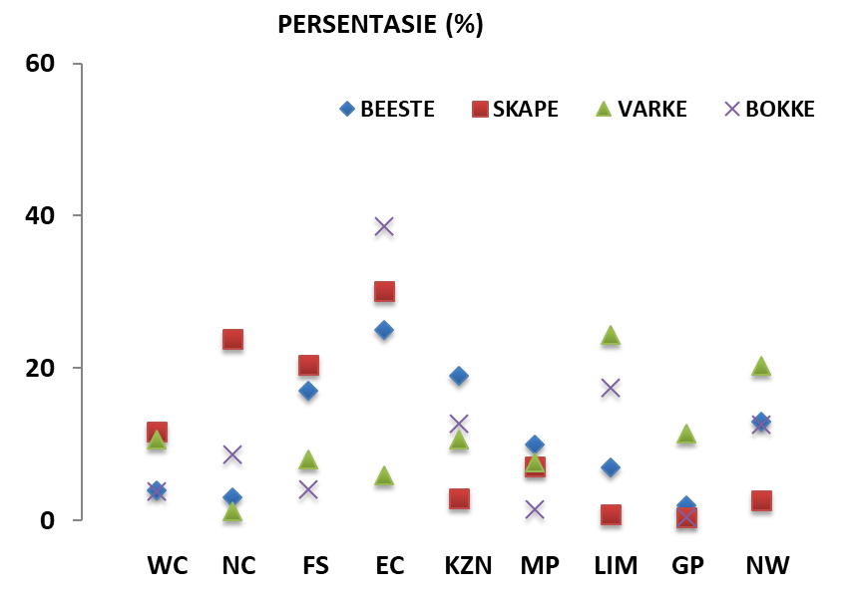
BEESTE: Die meeste beeste word in die Oos-Kaap aangetref, gevolg deur KwaZulu-Natal en dan die Vrystaat.

SKAPE: Die hoogste getal skape word in die Oos-Kaap gevind, gevolg deur die Noord-Kaap en dan die Vrystaat.

VARKE: Die meeste varke word in Limpopo aangetref, gevolg deur Noordwes en dan die Gauteng and Wes-Kaap.

BOKKE: Oos-Kaap het die meeste aantal bokke, gevolg deur onderskeidelik Limpopo en KwaZulu-Natal.

NOTAS (SEP 2020 – NOV 2020)

Reën: Die land het gedurende die tydperk steeds onder normale reënval aangeteken. Sommige dele van NC en KZN het droogte beleef.
Vee: Vee-toestande wissel gemiddeld tussen redelik en redelik. In die meeste gevalle het boere hul kuddes aangevul. Limpopo het veediefstalsake aangeteken. 'n aantal provinsies het sterftes aangeteken, met F&M in LIM, brande in LIM en KZN, en elektrisiteit in NW.
Weiding / veld: Die toestande was gemiddeld swak om droog te word, met veldbrande in LIM, KZN en NW.

Dit sal waardeer word indien u die meegaande veeskattingsvraelys sal voltooi en dit voor 30 April 2021 in die ingeslote koevert sal terugstuur. Of e-pos na Livestock@daff.gov.za
Die Direktoraat wil u graag bedank vir u volgehoue samewerking.
per pro. Direkteur: Statistiek en Ekonomiese Analise

Newsletter: National Livestock Statistics

From: Baldwin Netshifhefhe Directorate: Statistics and Economic Analysis
Tel: 012 319 8043 Fax: 012 319 8035/1 E-mail: BaldwinN@daff.gov.za / SelebogoL@daff.gov.za

Dear Co-operator FEBRUARY 2021

Estimated Livestock Numbers in the RSA (August 2020 and November 2020)

Province | Cattle |  | Sheep |  |  |  | Pigs |  | Goats
 | Aug-20 | Nov-20 | Aug-20 |  | Nov-20 |  | Aug-20 | Nov-20 | Aug-20 | Nov-20
 | Thousands
Western Cape | 466 | 470 |  | 2 545 | 2 507 | 144 |  | 143 | 202 | 201
Northern Cape | 419 | 415 |  | 5 182 | 5 107 | 17 |  | 17 | 448 | 446
Free State | 2 054 | 2 041 |  | 4 330 | 4 363 | 109 |  | 108 | 215 | 213
Eastern Cape | 3 050 | 3 074 |  | 6 513 | 6 439 | 81 |  | 80 | 1 991 | 1 987
KwaZulu-Natal | 2 380 | 2 363 |  | 628 | 623 | 143 |  | 143 | 662 | 655
Mpumalanga | 1 248 | 1 243 |  | 1 527 | 1 517 | 104 |  | 103 | 77 | 76
Limpopo | 860 | 854 |  | 199 | 195 | 329 |  | 330 | 902 | 902
Gauteng | 246 | 246 |  | 84 | 83 | 155 |  | 153 | 21 | 21
North West | 1 576 | 1 564 |  | 596 | 587 | 275 |  | 274 | 651 | 646
Total | 12 298 | 12 270 |  | 21 605 | 21 421 | 1 357 |  | 1 351 | 5 170 | 5 147
The numbers for cattle, sheep, pigs and goats decreased by approximately 0.23%, 0.85%, 0.44% and 0.44% respectively between August 2020 and November 2020.
CATTLE: Eastern Cape has the highest percentage of cattle, followed by KwaZulu-Natal and Free State.

SHEEP: The highest percentage of sheep is in Eastern Cape, followed by Northern Cape and Free State.

PIGS: Pigs are largely in Limpopo, followed by North West, Gauteng and Western Cape.

GOATS: Eastern Cape has the highest number of goats, with Limpopo and KwaZulu-Natal following respectively.

NOTES (SEP 2020 – NOV 2020)

Rain: The country continued to record, on average, below normal rainfall over the period. Some parts of NC and KZN experienced drought.
Livestock: On average, livestock conditions ranged between fair to reasonable. In most cases, farmers were supplementing their herds. Limpopo recorded stock theft cases. A number of provinces recorded mortalities, with F&M in LIM, fires in LIM and KZN, and electrocution in NW.
Pasture/veld: Conditions were poor to dry on average, with veld fires in LIM, KZN and NW.
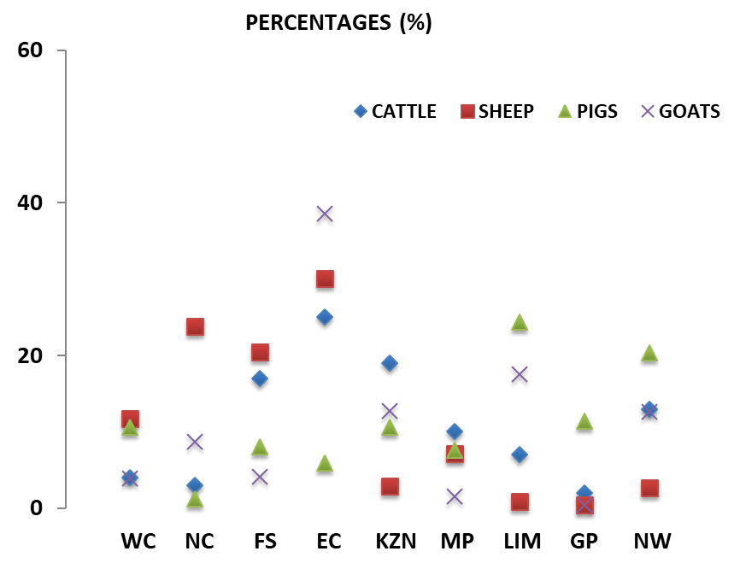

The Department will appreciate if you could complete the enclosed livestock questionnaire and send it back before 30 April 2021, in the envelope provided. Alternatively, send to this email: Livestock@daff.gov.za
The Directorate appreciates your continued support.
per pro. Director: Statistics and Economic Analysis

